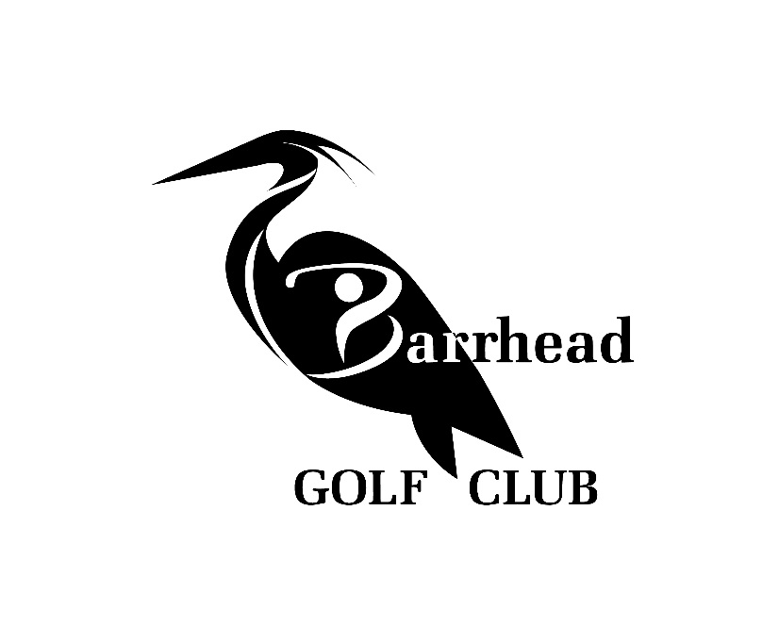

Barrhead Golf Club
2023 Tournament Package

Thank You For Your Interest In Our Facility.
If You Have Any Questions Regarding Your Function
Please Call Kevin Lynes At (780) 674-3053
Or Toll Free At 1-888-674-3053

www.golfbarrhead.com
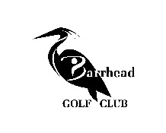

Tournament Green Fees

Company Name/ Name Of Function_________________________________________

Contact Person__________________________________________________________

Telephone____________________________Fax_______________________________

Date Of Function______________________ Starting Time______________________

Number Of Players____________ 9Holes____ 18Holes____

9 Hole Rate Weekday $25.00 Weekend $38.00
*9 hole play will only be honored after 1:00 PM on weekends

18 Hole Rate Weekday $40.00 Weekend $60.00

Power Cart Requirements Yes____ No____ Number Required____
*Prebooked Power Carts will be charged to the tournament-Otherwise power carts will be on a first come first serve basis. Per Person Cart Rates 9 Holes $15.00 18 Holes $40.00

Rental Clubs Required Yes____ No____ Approx #____
9 holes-$15.00 18holes-$20.00

Special Requests/Proximity Markers(Long Drive ect.)__________________________

Barrhead Golf Club P.O. Box 4090 Barrhead, AB T7N-1A1 Tel. (780)674-3053 Fax (780)674-3638

www.golfbarrhead.com

Tournament Banquet Package 2023

Chicken Dinner
Seasoned Grilled 6oz chicken breast served with roasted garlic baby potatoes, Caesar salad, second salad of chefs choice, vegetable & dessert.
Price per person: $ 26.95

Roast Beef Dinner
Slow-roasted certified angus beef served with Yorkshire pudding, mashed or baked potatoes, gravy, vegetable, and dessert.
Price per person: $ call for quote

Steak Dinner
Our 6oz or 8oz Certified Angus Beef steak is served with baked potato, baked beans, Caesar salad, vegetable or second salad of Chef’s choice, garlic toast & dessert.
Price per person: $ 27.95(6 oz), $ 29.95(8 oz)

BBQ Burger Dinner
Fresh certified burger served with all the trimmings, in-house potato or macaroni salad, vegetable or second salad of Chef’s choice, baked beans & dessert.
Price per person: $ 19.95

Vegetarian options are available, please contact for request

Prices do not reflect GST or 15% gratuity.
Barrhead Golf Club P.O. Box 4090 Barrhead, AB T7N-1A1 Tel. (780)674-3053 Fax (780)674-3638

